File Organizer - Project Report

**Name: Mohsin Zeb**

**Intern ID:** **TN/IN02/PY/019**

**Email ID : mohsinzebsm@gmail.com**

**Domain: Python Development**

Introduction

The File Organizer is a Python-based application designed to automatically organize files in a directory based on their extensions

CODE:

|  |
| --- |
| import os  import shutil  path = input("Enter Location:" )  files = os.listdir(path)  for file in files:    filename, extension = os.path.splitext(file)    extension = extension[1:]      if extension == "":  continue  if os.path.exists(os.path.join(path, extension)):    shutil.move(os.path.join(path, file), os.path.join(path, extension, file))  else:    os.mkdir(os.path.join(path, extension))    shutil.move(os.path.join(path, file), os.path.join(path, extension, file)) |

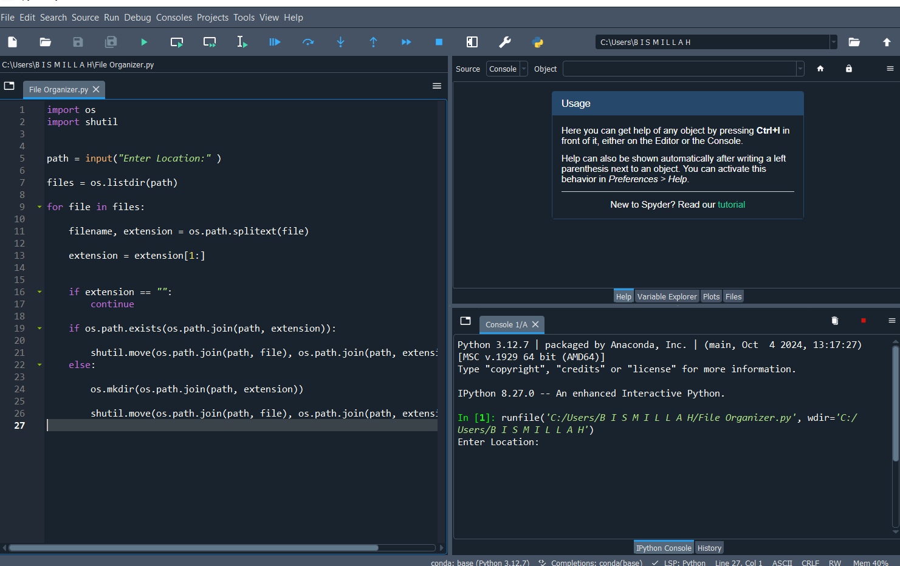

How It Works

* + Specify the directory path to organize.
  + Program scans path and files and identifies their types through their extension by listing them first.
  + It will create the Folders for those files

OUTPUTs:

BEFORE:

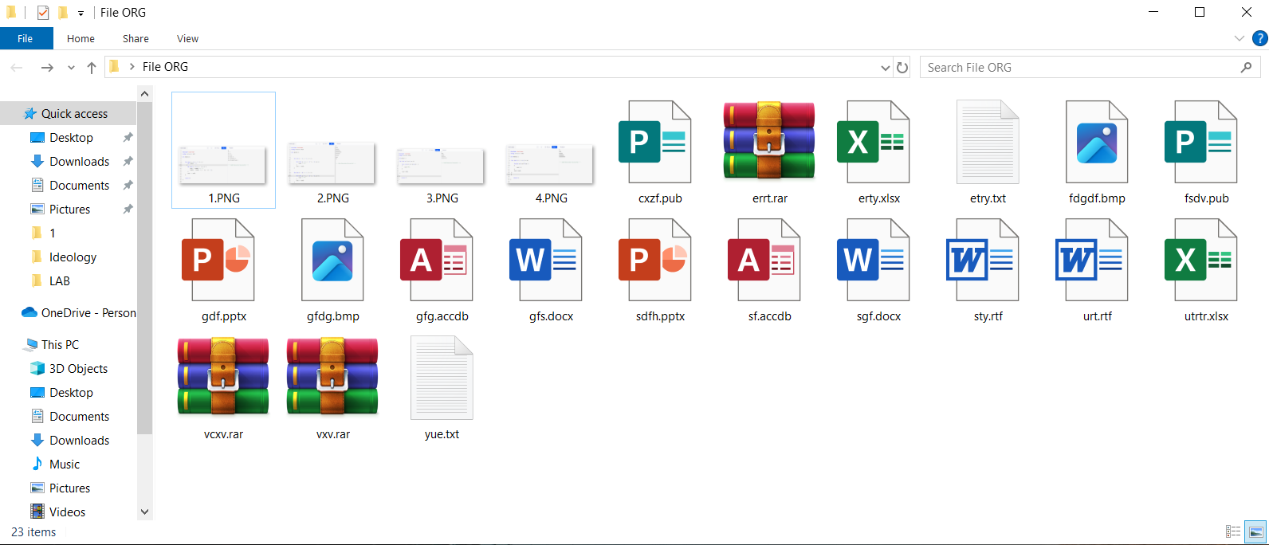

AFTER:

